­Client Contact Details

Technical Proposal

Software Quality Assurance Managed Services

We Engineer Your Digital Success



Prepared by:

Verbat Technologies

Prepared for:

Majid Al Futtaim Retail (Carrefour)

Document Issued: 28 July 2016 Proposal No: Q/AD/TP/08062016/1218/2





|  |  |
| --- | --- |
| **Software Quality Assurance Managed Services** | |
| **Leena Musar**  **e-Business System Development Manager** | **M**:+971 56 179 5124 |
| **Email:** Lmusar@mafcarrefour.com |
| **Address:** Carrefour UAE HO , 1st Floor Shindagha City Center, Dubai, UAE |

Verbat Contact Details

|  |  |
| --- | --- |
| **Dubai** | |
| **Lekshmi Krishna**  **Project Coordinator** | **P:** +971 4 2973236 |
| **Email:** [lekshmi.krishna@verbat.com](mailto:lekshmi.krishna@verbat.com) |
| **Dubai Office Address:**  217, Sheikh Rashid Bldg.  P.O Box 56272,  Dubai, UAE |

|  |  |
| --- | --- |
| **Dubai** | |
| **Deepthi R Krishna**  **Head - Middle East Business** | **P: +971 4 2973236** |
| **Email:** [deepthi.krishna@verbat.com](mailto:deepthi.krishna@verbat.com) |
| **Dubai Office Address:**  217, Sheikh Rashid Bldg.  P.O Box 56272,  Dubai, UAE |

Statement of Confidentiality: This proposal and supporting materials contain confidential and proprietary business information of Verbanet Technologies LLC. These materials may be printed or photocopied for use in evaluating the proposed project, but are not to be shared with other parties

­

Table of Contents

1 Executive Summary 5

1.1 The Context 5

1.2 Solution Objective 5

1.3 Why Verbat 6

1.3.1 Our Philosophy 6

2 Verbat Proposition 7

2.1 Approach 7

2.2 Our Testing & Quality Assurance Services 8

2.3 Test Management 8

2.4 Test Work Flow 9

2.5 Test Process Improvement 10

2.5.1 Methodologies 10

2.5.2 Initiate and Plan 10

2.5.3 Requirements Analysis Phase 11

2.5.4 Design Phase 12

2.5.5 Build Phase 12

2.5.6 Test Phase 13

2.5.7 Load Test/ Performance Test 14

2.5.8 Preparation of Order in an Order Management System (OMS) 24

2.5.9 Update of product in Product Content Management System (PCM) 24

2.5.10 Creation and update of a template in Content Management System (CMS) 25

2.5.11 Configuration of the search engine 26

2.5.12 Administration of the delivery slots, promotions in Hybris Management Console (HMC) 27

2.5.13 Test Scenarios 28

2.5.14 Test Reports 29

2.5.15 Deploy and Warranty Phase 29

2.6 Deliverables 30

2.7 Benefits 31

2.8 Technical Response (Annexure A) 32

2.9 Assumptions 34

2.10 Summary of Proposition 35

3 Delivery Management 36

3.1 Project Management 36

3.2 Roles and Responsibilities 36

3.3 Team and Governance 36

4 General Terms and Conditions 37

5 Company referees 38

5.1 Client Name – Barcode Gulf 38

5.2 Client Name – CCC 38

6 Our Other Clients 39

# Executive Summary

## The Context

Client has approached Verbat Technologies (hereafter referred as Verbat) to provide Software Application Testing and Software Quality Assurance managed services. Verbat is pleased to have received the request to submit the proposal and values it as a great opportunity to have a long term & mutually beneficial association with the client. Verbat has gone through the requirement and presents a proposal for the requested system.

This technical document covers the solution as specified below.

## Solution Objective

The core objective is to provide software application testing and software quality assurance managed services for the client

Verbat offers a comprehensive suite of Testing & Quality Assurance Services, providing Test Management, Test Automation, Test Process Improvement, Performance Testing and Consultancy. With extensive experience and expertise in a range of Testing & Quality Assurance services and solutions, Verbat has contributed to Testing & Quality Assurance engagements across many industries and sectors.

Our engagement context is as below

* Support client in the area of digital solutions testing
* Design and develop the Testing Strategy, Guideline and Roadmap
* Perform the Regression testing (Automated/Manual), Performance Testing (Load/Stress), assist UAT for the Applications in close coordination with the client and developer
* Test Preparation, Test Execution

## Why Verbat

Verbat is a globally accredited software consultation partner that has over 16+ years of experience in assisting global corporations with their IT strategy, application development, maintenance & testing, information management and digital marketing efforts.

Spearheaded by a team of technology and management leaders, Verbat has today grown into a multi fold IT service consultant with service interests in Retail, Logistics, Construction & Contracting, Fashion, Government, Enterprise Management, Banking, Manufacturing, Hospitality, Automotive, Healthcare etc. to name a few.

## Our Philosophy

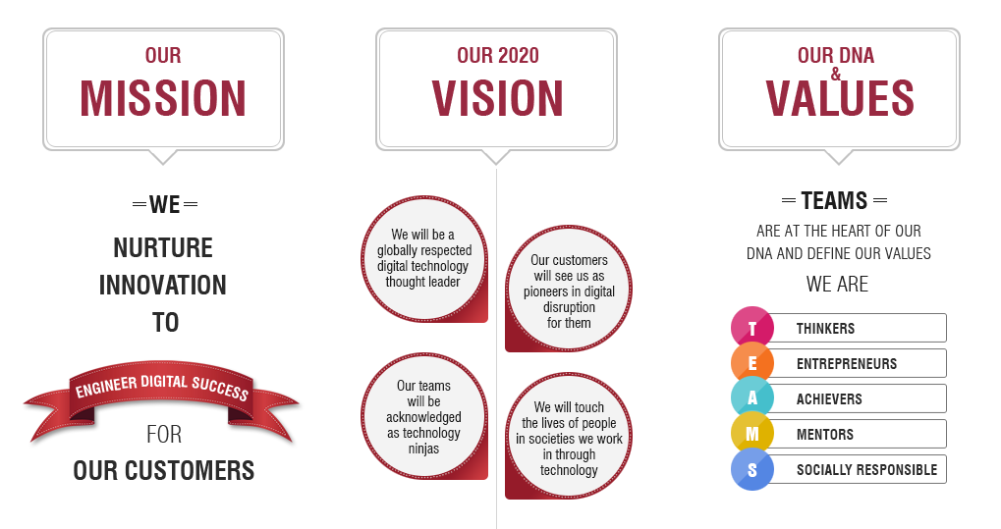

Verbat offers the following strengths and differentiators that extend our position as the Industry Leaders in software testing:

* Proven experience of running Testing programmers;
* Proven experience of end-to-end Testing services for various industries;
* Hybris testing experience for about 1.5+ years
* Experience of successfully executing Testing engagements, some with sizes of 25+ Test professionals;
* Availability of the right mix of local &Right shore test professionals with worldwide presence;
* Innovation and industrialization processes that ensure continuous reuse of Test Conditions for specific domains;
* Proven framework to improve Test Maturity through Quality Blueprints (QBP);
* Proven capabilities in setting up Accelerated Test Centers of Excellence for Client Organizations;
* Proven consulting capabilities, such as Test Consulting & the Accelerated Solutions Environment (ASE);
* Technology Centres of Excellence (CoEs) comprising of: Automation CoE, Performance CoE, Security CoE, Data Management CoE, Environment CoE and BI CoEs ensuring that the latest trends are being studied and industrialized within the Practice and with our customers.

# Verbat Proposition

## Approach

**Our approach and solution brief**

* Procure Traceability Matrix to map Requirement , UI, Development, Testing and UAT
* Obtain Work Packages or equivalent deliverables from the development team
* Create test plan and test cases & perform necessary testing on the requirements detailed in the work packages; including Functional & UI Testing
* Comply with the Test Governance and submit KPI/ Status Reports to the board in addition to bi-monthly meetings

Verbat testing process framework uses a structured approach for each phase of testing across SDLC. Verbat proven testing methodology and framework: Our process manual describes the following activities in a testing phase: estimations, planning, and preparation, execution, reporting (including guidelines), checklists, and templates on each activity. The process framework supports the following SDLC: waterfall, iterative, Agile, RUP, V-model SDLC, new development and enhancement.

Our Highlights are described below:

* It delivers insight into and advice on any risks in respect to the quality of the tested system;
* It is designed to discover defects at an early stage;
* The testing is on the critical path of the total development as briefly as possible, so that the total lead time of the development is shortened;
* Testing is executed as briefly as possible to shorten development lead time;
* The test products (e.g. test cases) are reusable;
* The test process is comprehensible and manageable.

The adaptive and flexible test method has the following characteristics:

* Our approach can be applied to all test situations;
* The complete and flexible approach works for all SDLC (e.g. waterfall, Agile, etc.);
* The approach is independent of technology and is responsive to changes;
* The approach has reusable products and processes and builds on lessons learned from experience, including prototyping.

## Our Testing & Quality Assurance Services

Verbat offers a comprehensive range of Testing and Quality Assurance Services, which can be purchased either in combination or individually.

## Test Management

Verbat proprietary test management methodology provides a clear and concise approach that focuses on detecting defects early through quality checks while identifying, quantifying, and mitigating risk. An integral part of the methodology, business driven test management assesses project/product risks to increase visibility and improve decision making.

Verbat Managed Testing Services (MTS) is a structured solution, providing clients with the test organization, processes, and environment that will achieve optimum results and dependable state-of-the-art software that performs time after time.

MTS is a fully customized service in which we take responsibility for test activities at either enterprise or program level. A collaborative approach to sourcing testing and QA services, MTS is the solution for clients who want to transform their testing function and achieve high-quality systems cost-effectively, without the expense of large overheads and day-to-day responsibilities, and without losing overall control

## Test Work Flow

Figure 1: Test Work Flow



## Test Process Improvement

Verbat uses the test management approach to drive test process improvement together with our client. The approach offers the following advantages:

* The client manages the test process rationally and economically: Business Driven Test Management (BDTM);
* The approach is adaptable to test situations in most environments (e.g. new development, maintenance, waterfall/iterative/agile development, customized or package software, outsourcing);
* The comprehensive test process, from test execution through test management, includes best practice and examples;
* Contains a complete ‘tool set’, i.e. technique descriptions and organizational and infrastructure support.

### Methodologies

Testing will be ensuing these types of Test methodologies to be performed in the application

* Functional Tests
* Integration Testing
* System Testing
* Smoke Testing and Sanity Testing
* Regression Tests
* User Acceptance Tests

### Initiate and Plan

QA is involved early in the SDLC to contribute to the overall project charter from a QA strategy perspective and to support the project from a testing perspective. Early involvement of the QA Lead reduces the knowledge transfer effort for the Test Teams.

### Requirements Analysis Phase

The Requirements Analysis Phase incorporates the Planning and Control phases when creating functional requirements. This provides the basis for a manageable and high quality testing process. The value of the development planning, the expected quality of the test object, the organization of the various tasks and the availability of staff, infrastructure and time are factors that are taken into account in determining the test estimation and approach.

|  |  |  |
| --- | --- | --- |
| **Requirements Analysis Phase Activities** | | |
| Key Deliverables | Quality Checks | Action Plan |
| Test Estimation  Test Estimation  Test Strategy, Test plan  Organizational Structure  Risk Analysis Report  Requirement Review Report | 2 Review | Define and receive  Approval on approach  And scope. Initial Quality  Check on requirements. |

### Design Phase

The first activity during this phase is knowledge acquisition of the Test Team. Once the first version of the specification is ready with an adequate level of quality (e.g., most imperfections have been removed) the actual preparation activities can begin. This phase consists of detailed review of the specification and other documentation that serve as the starting point for testing (Static Testing).

|  |  |  |
| --- | --- | --- |
| **Design Phase Activities** | | |
| Key Deliverables | Quality Checks | Action Plan |
| Test Estimation  Test Techniques matrix  Test Techniques Matrix  Test Scenario  Traceability Matrix  Infrastructure/Environment  Needs Reports | Static Testing-Design  Review  Testability Review  Test Coverage | Detailed review of  functional specification  To gain knowledge, identify  deficiencies and  recommended improvements  Test Scenario identification  Covering testable  Requirements. |

### Build Phase

In this phase, the test cases are specified and the accompanying test infrastructure is realized. A test case consists of a description of the input, the process to be executed, and a prediction of the expected output. In parallel to the test design, the test infrastructure (the hardware and software environment, etc.) is constructed. Developers conduct unit tests during this phase and unit tests are reviewed and verified by the QA Team.

|  |  |  |
| --- | --- | --- |
| Build Phase Activities | | |
| Key Deliverables | Quality Checks | Action Plan |
| Test Estimation  Test Techniques matrix  Test case/Test scripts  Test data needs report  Unit test report  Test design matrix | Code review  Unit testing  Unit test report review  Validate infrastructure  Test readiness review | Detail test scenario in test scripts, review of unit test phase, identification and communication of the data needs, validating the infrastructure. |

### Test Phase

The Verification Phase starts as soon as the first testable components of the software product are available and align to Execution Phase When (parts of) the software product, the infrastructure and the test database are available, the first pre-tests are executed to check whether the main functions of the object can be tested. As soon as the pre-tests have been completed successfully, test execution can start using the test scripts to validate the functionality. If there is a difference between the test result and the expected result, it indicates a software product or specification defect, a defect in the test infrastructure, or an invalid test case.

|  |  |  |
| --- | --- | --- |
| Test Phase Activities | | |
| Key Deliverables | Quality Checks | Action Plan |
| Test Estimation  Test Techniques matrix  Test execution report  Defect status report  Execution and defect metrics  Phase end summary report  Process compliance report | Integration testing  Regression testing  System testing  Performance testing  Automation (if applicable) | Execute test at different test levels, log and track defects closure, capture relevant metrics. |

### Load Test/ Performance Test

Load testing is an essential stage in the development lifecycle, which ensures that applications don't buckle under heavy load. When a software system is deployed by an organization, it may encounter many scenarios that possibly result in performance latency. A number of factors cause decelerating performance. Few examples include:

* Increased number of records in the database
* Increased number of simultaneous requests made to the system
* Larger number of users accessing the system at a time as compared to the past

Our user-friendly Website Load Testing service allows client to control these processes. We offer tailor made solutions based on client’s technical and business requirements. We mainly use two tools for load testing:

* HP LoadRunner
* JMeter

### LoadRunner

LoadRunner supports various development tools, technologies and communication protocols. In fact this is the only tool in market that supports such large number of protocols to conduct performance testing. LoadRunner is not only a pioneer tool in Performance Testing, but it is still the market leader in the Performance testing paradigm. In a recent assessment, it was noted that LoadRunner has about 85% market share in Performance testing industry. LoadRunner supports RIA (Rich Internet Applications), Web 2.0 (HTTP/HTML, Ajax, Flex and Silverlight etc.), Mobile, SAP, Oracle, MS SQL Server, Citrix, RTE, Mail and above all, Windows Socket. There is no competitor tool in the market which could offer such wide variety of protocols vested in single tool. What is more convincing to pick LoadRunner for performance testing is the credibility of this tool. LoadRunner has long established reputation, as often you will find clients cross verifying your performance benchmarks using LoadRunner. LoadRunner works on a principal of simulating Virtual Users on the subject application. These Virtual Users, also termed as VUsers, replicate client's requests and expect corresponding response to pass a transaction.

**A demonstration of how LoadRunner works.**

The advantage of LoadRunner is we could provide multiple numbers of users as vusers using multiple scenarios for a variable time and results can be easily analysed by various outputs in the form of tables to graphs. Attached below are the screen shot of small example of a famous online e-commerce platform [www.amazon.in](http://www.amazon.in) simultaneously tested for 3 users at a time.

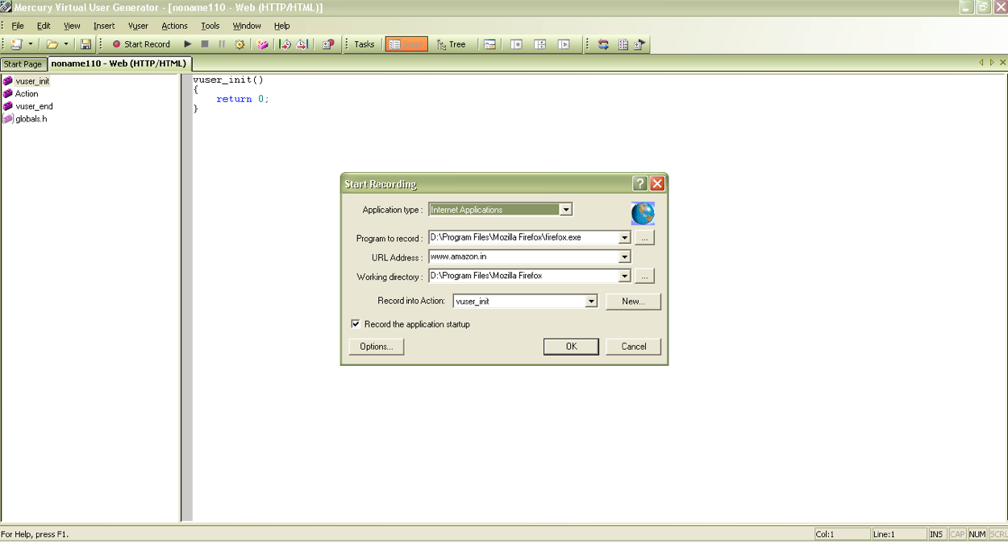

Figure 2: Start recording window where we want to perform the load test

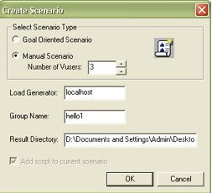

Figure 3: Select the Scenario according to the requirement

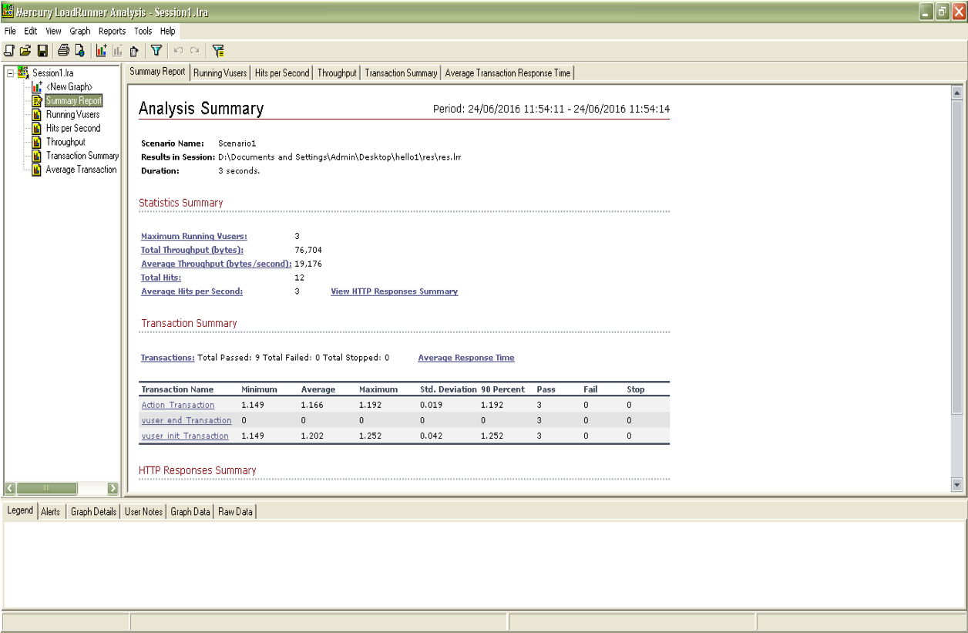

Figure 4: After recording and running the scripts with specified number of users the result is displayed for detailed analysis

**JMeter**

The Apache JMeter is pure Java open source software, which was first developed by Stefano Mazzocchi of the Apache Software Foundation, designed to load test functional behaviour and measure performance. You can use JMeter to analyse and measure the performance of web application or variety of services. Performance testing means testing a web application against heavy load, multiple and concurrent user traffic. JMeter originally is used for testing Web Application or FTP application. Nowadays, it is used for functional test, database server test etc.

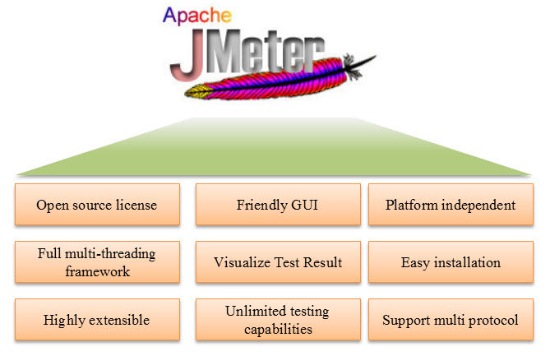

Figure 5: The main advantages of JMeter illustrated

JMeter simulates a group of users sending requests to a target server, and return statistics information of target server through graphical diagrams and other formats.

**A demonstration of how JMeter works:**

Attached below are the screen shots of small example simultaneously tested for many users at a time.

The working of JMeter is mainly in 4 parts as illustrated below:

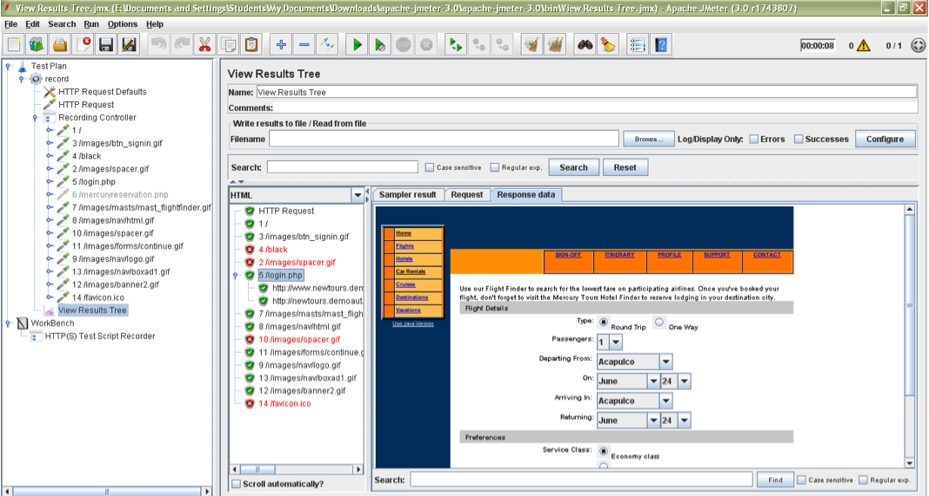

Figure 6: Sending request to the server to be tested and recording the script and different scenarios

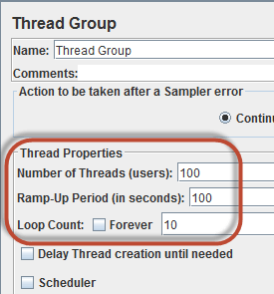

Figure 7: Giving the number of virtual users for a specified time and repetition count

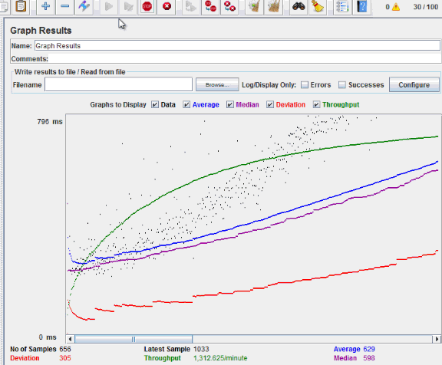

Figure 8: Results are displayed in graphical format for the webpage [www.newtours.demoaut.com](http://www.newtours.demoaut.com)

From the results the throughput of website under test [www.newtours.demoaut.com](http://www.newtours.demoaut.com)is 867.326/minutes. It means the requested server can handle 867.326 requests per minute.

### Test Scenarios

A scenario is a story that describes a hypothetical situation. In testing, you check how the program copes with this hypothetical situation. The ideal scenario test is credible, motivating, easy to evaluate, and complex. Scenarios are usually different from test cases in that test cases are single steps and scenarios cover a number of steps. Test suites and scenarios can be used in concert for complete system tests.

The exhaustive testing is not possible due to large number of data combinations and large number of possible paths in the software. Scenario testing is done to make sure that end to end functionality of application under test is working as expected. Also check if the all business flows are working as expected.

Our team has created test scenarios templates for different projects as time is an important factor in all our products. As we get our functional specification document we modify the scenario according to the specified document.

Attached below is the screen shot for the test scenario template created by our sap specialist test consultant

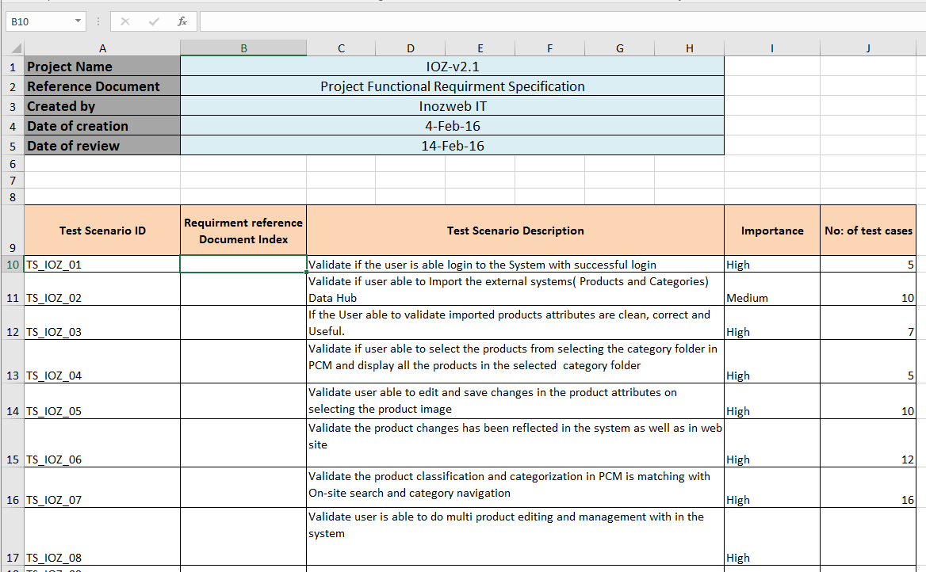

Figure 9: Screen shot for the test scenario template created by our sap specialist test consultant

### Test Cases

### Test Case is ‘How to be tested’ and Test Scenario is ‘What to be tested’. So if test scenario is the backbone of our performance test case is how to create the backbone. So we take special care in finding out all the possible cases according to different scenario and the functional specification document. Attached below are some of the previous projects test cases and test plan structure

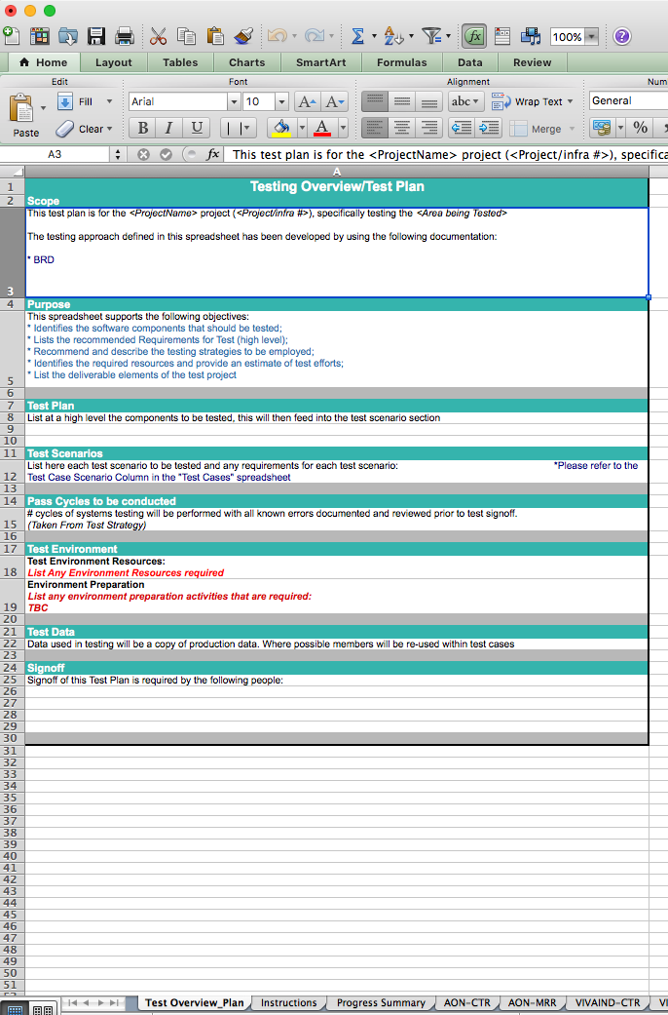

Figure 10: Test plan Template

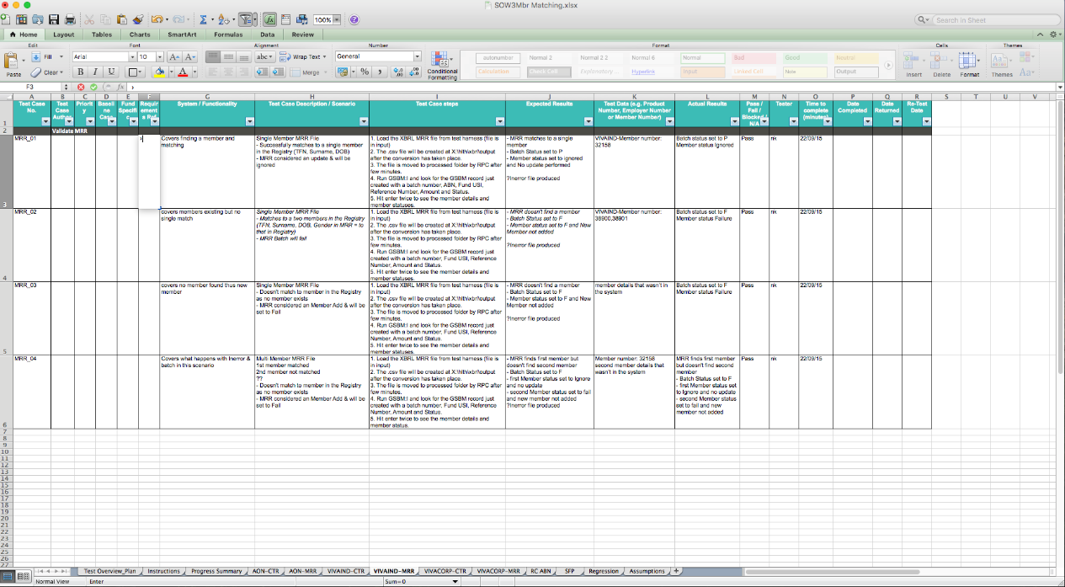

Figure 11: Test case and its execution.

### Test Reports

When reporting results from a usability test, you should focus primarily on your findings and recommendations that are differentiated by levels of severity. Include the pertinent information from the test plan and present just enough detail so that the method is identifiable. Keep the sections short, use tables to display the metrics, and use visual examples to demonstrate problem areas, when possible.

In general, report includes a background summary, our methodology, test results, findings and recommendation

We include an analysis of what the facilitator and data loggers recorded. Describe the tasks that had the highest and lowest completion rates.  Provide a summary of the successful task completion rates by participant, task, and average success rate by task and show the data in a table. Follow the same model for all metrics.

As test report is an important factor in analysing the quality of a product we also take special care to make it easy for the developing teams to review the defect and understand it easily. So we include the following things in our report.

* **Screen shots to readers visualize what we were testing.** Include parts of screens to illustrate specific areas that are working particularly well or that are causing problems for users.
* **Short video clips to illustrate specific points**, if we are presenting the report electronically and the readers of the report have the technology available to see video clips. People who did not observe the actual test sessions are often most convinced of problems and the need to fix them by watching and listening to relevant video clips.

## Jira for managing and raising defects

JIRA Project is a collection of Issues, governed by Schemes for Issue Types (bug, enhancement, feature request, etc.) Screens (what is visible and when it is visible), Workflows (you can have a single project with multiple workflows tailored to each issue type; a defect may require additional steps versus a new feature), Permissions (who can do what to an issue), and Notifications (what messages are transmitted to who and at what point in the workflow). All of these can be rendered graphically using plugins.

Few screenshots of our project done in JIRA is also shown below

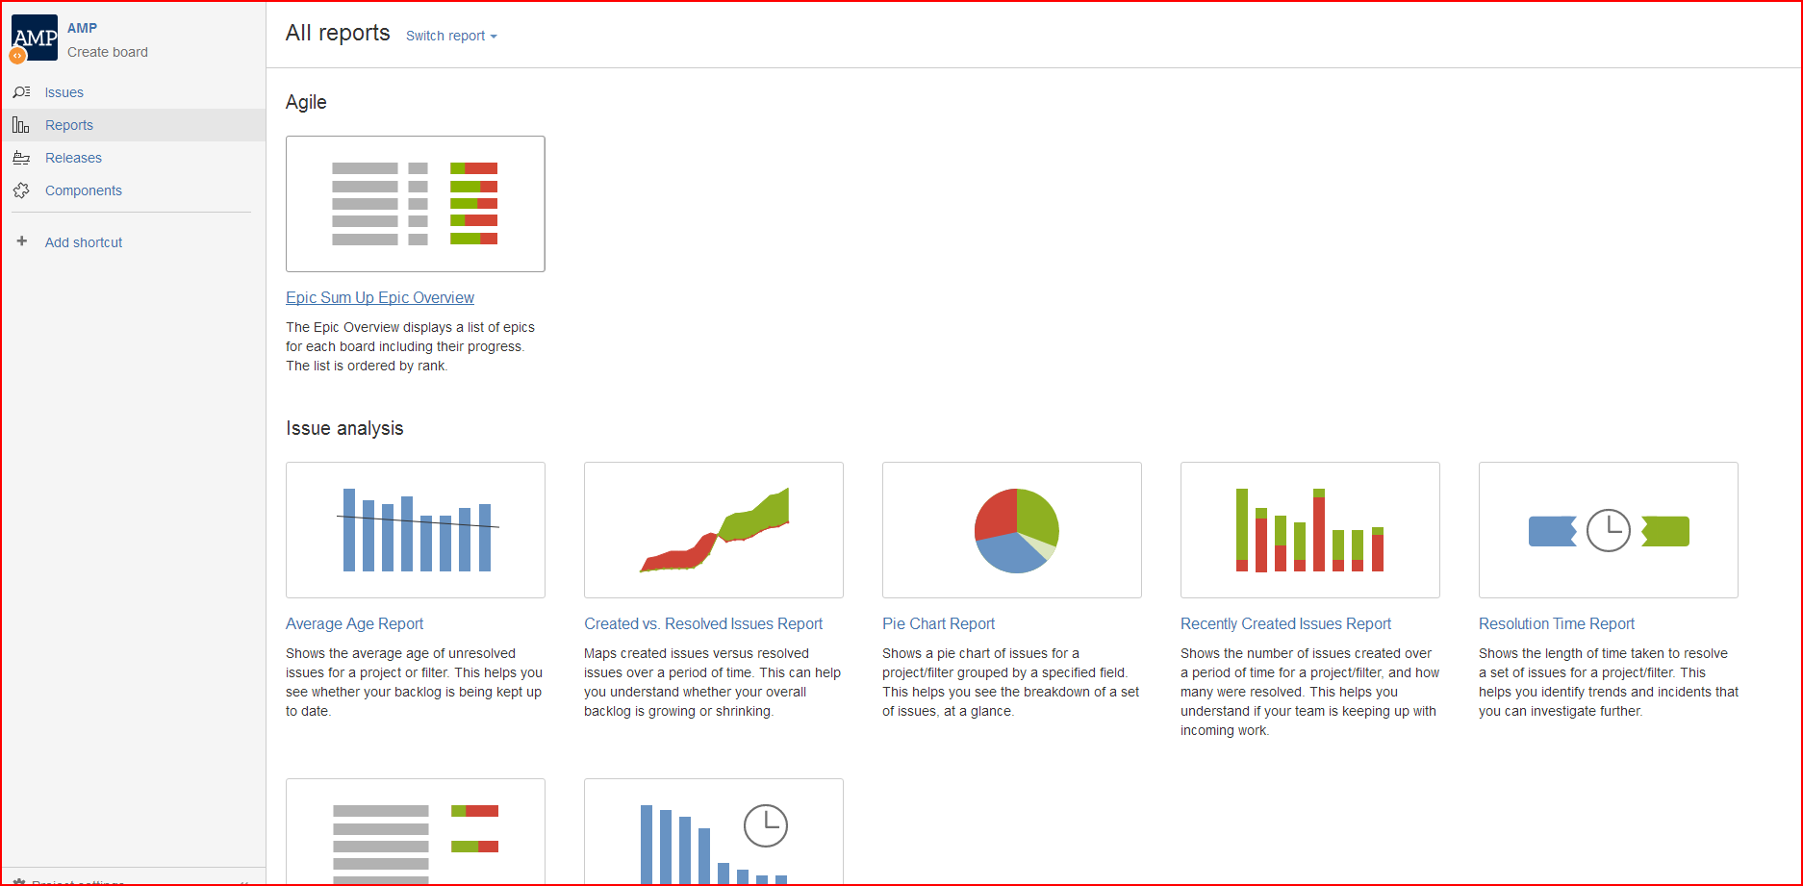

Figure 22: shows how to view the report

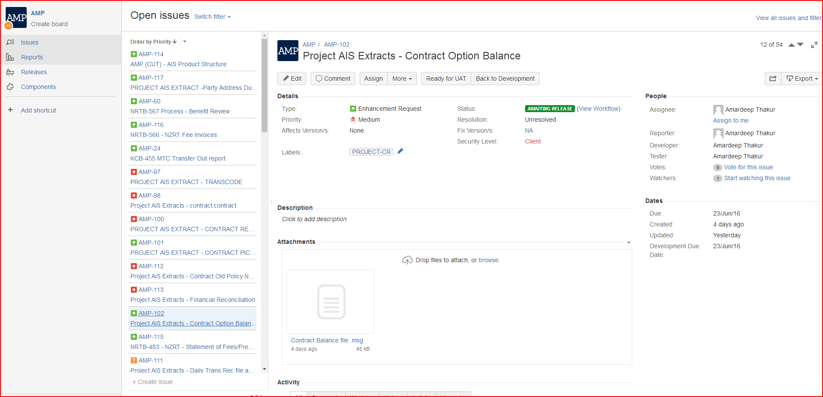

Figure 13: Bug logged and tracked and arranged according to the priority and visual attachment can also be seen

# Backend/Database Testing

For a bug free and high performance of your application, we need to test its back end. Back end/database testing is a separate area of testing which is categorised as white box testing. Backend testing will also have same importance as functional testing.

E.g.: If we have a registration form, and if we only have a UI where there must be some input fields and a submit button. Most common test is to fill the form and verify weather that user is created or not. but wouldn’t necessarily know what is happening at the database. Taking this example, we first gain full knowledge of our database. Which field is mapped with which table and what are the columns where data will be inserted.

We currently use SQL developer/ query as the database management tool and all our consultants are well trained in using these specified systems.

In DB testing we are mainly using with SQL Developer.

Connection property XML will share by the client side and DB details are provided with table names by development team. DB mainly use to check the Product information in the table like promotion associated items, Item inventory remaining

DB testing, we are only doing the data retrieval process using ' SELECT ' Query.

So in every project we ensure

* Data integrity-The complete data belonging to each entity should be stored in the database. There should not be any missing data
* Correctness of the data stored in the database- The data stored should be correct and stored in right place.
* Data type testing
* Data size testing- Generally we test Data size only at the front end, but it is essential to test it at back end separately
* Database performance
* Data security
* In case of data migration check Correctness and completeness of data
* Input Item verification- In this we verify the input items like text box, combination box, active X controls. Generally, ask developer to test this during unit testing.
* All Stored Procedures if applicable will be separately tested

- The no. of arguments being passed  
- The data type of each of the arguments being passed  
- The order of the arguments being passed  
- The return value  
- The data type of the return value

We conduct performance testing using LoadRunner/ JMeter which are the market leaders in performing load tests. Time, Quality and ROI are the main things we keep in mind while working on a project.

### Application Overview Diagram

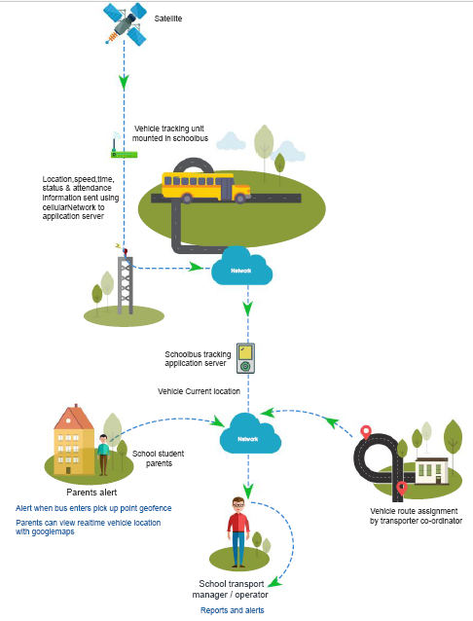

The School bus tracking application consist of the following modules that needs to be tested

* Web Application consisting of
  + Admin Module
  + Parent Module
* Mobile Application consisting of
  + Transport Manager App
  + Driver Console (Tablet)
  + Driver Console (Mobile)
  + Bus Attendant App
  + Parent App

Test Strategy for services that are assumed to be developed for the software application being developed

### System Features

Testing will be conducted for system wide features such as

* Upload data via Excel to major modules (student, bus-attendant, driver, teachers)
* Hardware configuration testing
* Application Audits
* Application logs
* Authentication
* Authorization
* GPRS location testing
* Application configuration

### Mobile App

#### Transport Manager

The following functionality will be tested

* Monitoring the fleet
* Create new routes
* Assigning students to vehicles
* Creating and assigning Instant pickups
* Communicate with drivers by sending instant messages
* Approve Pick-up change request
* View device health of a particular vehicle

#### Driver Console (Mobile & Tablet)

Test instances for Mobile devices will be different from Tablet devices

* View route for each pick-up and drop-off
* View list of students boarding and un-boarding at each point
* View leave list of students for the day
* Mark student attendance
* Receive notification send by transport manager

#### Bus Attendant

Test functionality for

* Manually mark student attendance
* Reviewing student onboarding and off boarding details for each point
* Receive messages from transport manager and school authorities
* Updating pickup and drop off locations in case of detour

#### Parent application

Functionality to be tested

* Track bus location of their child
* Request pickup point change
* View attendance details
* Apply for student leave
* Communicate with school authority
* Update student information

### Web application

#### School Admin Module

* Management of users
* Management of students
* Management of routes and pickup points
* Sending messages to parents, bus-attendants and drivers
* Billing and invoice management
* Creation and management of scheduled and instant trips

#### Parent Module

* Track bus location of their child
* Request pickup point change
* View attendance details
* Apply for student leave
* Communicate with school authority
* Update student information

#### Teacher Module

* Communicate with parents on student progress in school
* View student leave list

### Test Scenarios

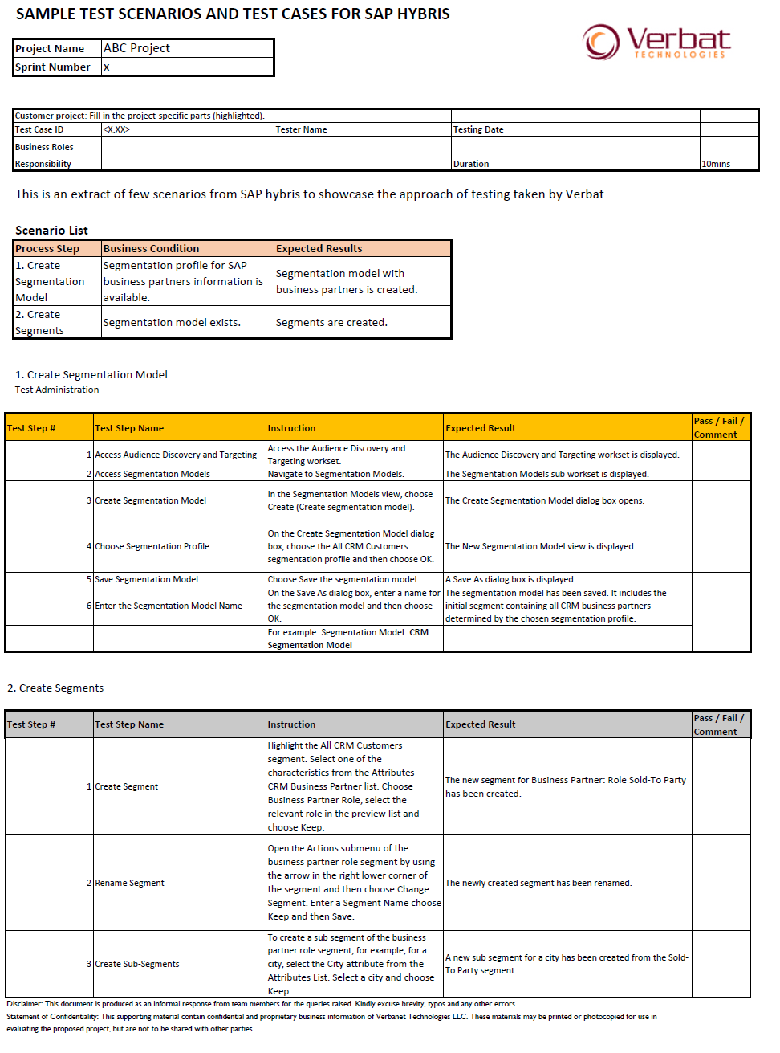

### Test Reports

The status reports will be provided by Verbat in the below mentioned KPI’s

* Active Defects
* Authored Tests
* Automated Tests
* Covered Requirements
* Passed Tests
* Rejected Defects
* Reviewed Requirements
* Severe Defects
* Test Instances Executed
* Tests Executed

### Deploy and Warranty Phase

The Deploy and Warranty Phase map to Completion Phase and warranty support period, which occur after the completion of test execution. After UAT, the testing process and the quality of the product are evaluated. Quantities of statistics are used to improve the future planning and optimization of the testing processes, development processes, and the quality of the system.

|  |  |  |
| --- | --- | --- |
| **Deploy and Warranty Phase Activities** | | |
| Key Deliverables | Quality Checks | Action Plan |
| Reusable test assets  Lessons learned & leading practice report | Evaluate test processes  Evaluate product quality  Capture defect leakage to  UAT and production | Facilitate UAT and support the maintenance phase.  Capture lessons learned Leading practice and evaluate processes, the knowledge base and product quality. |

## Deliverables

Below pictorial representation defines the deliverables from both client and Verbat.

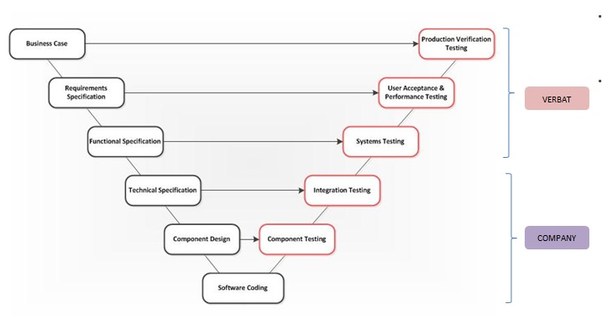

* Create testing scenarios based on client’s business processes and requirements; a test scenario seeks to emulate a real world business scenario with an expected output.
* These sorts of scenarios are executed against the system under test to ensure that the final solution delivered not only meets the business needs but is of a high quality.
  + Systems testing (End to End testing): Testing conducted on one, two or more systems that are needed to complete end to end business processes.
  + User Acceptance Testing: Testing conducted by the target business users. The objective of this test phase is to provide formal business acceptance of the entire solution prior to launch.
  + Production Verification Testing: The last phase of testing conducted as part of the implementation process prior to the official launch of the system.

## Benefits

Verbat understands the opportunities and challenges arising from Testing and Quality Assurance. Verbat offers a comprehensive portfolio of testing services that take a proven approach to industrialized and structured software testing. Our testing services maximize return on IT investment and deliver tangible benefits to organizations. Previous Verbat clients have benefited from:

* + Total cost of testing reduced by up to 30%;
  + Quality levels improved by preventing more than 97% of high-severity defects;
  + Time to market decreased by at least 15%;
  + Technical and business risks significantly mitigated

## Technical Response (Annexure A)

|  |  |  |  |
| --- | --- | --- | --- |
| **Sr. #.** | **Criteria** | **Response** | **Remarks** |
| T1 | Case Studies (up to 3) on Testing Projects executed | Ecommerce – smartserve  Retail - Limestone  Finance – Sanssouci  ERP - Paieroll |  |
| T2 | No. of Project management professionals (Including project managers and program managers). Specify Break-up for Testing and Non-  Testing, Onsite/off shore. | 30- project management professionals  20- test lead  32- non-testing | We will allocate resources based on the project requirement |
| T3 | Certified Testing Professionals -Certificates and respective number of professionals. | 16 certified testing professionals (ISEB,TIBCO & Software engineering and management &ISTQB) |  |
| T4 | No. of System Analyst and Business Analysts in Retail and e-commerce Domain. | 8- System Analyst  6- Business analyst |  |
| T5 | Bench Strength (%) for Testing  Resources. | 7 % |  |
| T6 | Lead time to ramp up/ down  Resources based on project Requirements. | 2 Weeks’ time |  |
| T7 | Total Testing staff strength in numbers. | 30 |  |
| T8 | Certifications: ISO 9001:2000/SElCMMi Level 5 / PCMM Level 5/ ISO 2700I Quality/ Six Sigma. | ISO 9001:2008 |  |
| T9 | No. of Testing projects executed (size greater than 50 person months)-Consolidated number as well as in Retail and e-commerce domain. | 40/8 |  |
| T10 | Total Testing Project (Years of related Experience) | 6 |  |
| T11 | Experience in testing with Automated Testing Tools/Framework. Specify  Tools/Framework used and years of experience. | QTP & Selenium |  |
| T12 | Testing Staff strength with  Automation Tool experience (specify tool and respective number of experienced professionals). | QTP -6  Selenium -10 |  |
| T13 | Testing Staff Strength with basic Database experience. | 7 |  |
| T14 | Project Success Ratio in Testing (%) | 95 % |  |
| T15 | Ready to work in on-site model. Specify pre-requisites if any. | Yes, on requirement basis |  |
| T16 | Total experience in Black box testing (Person Years). | 100+ |  |
| T17 | Total experience in White box testing (Person Years). | 100+ |  |
| T18 | Total experience in Performance Testing (Person Years). | 100+ |  |
| T19 | Total experience in Reliability testing (Person Years). | 100+ |  |
| T20 | Total experience in Auto testing (Person Years). | 100+ |  |
| T21 | Type of testing methodology used. | 1) Functional Tests  2) Smoke Testing  and  Sanity Testing  3) Regression Tests  4) Acceptance Tests |  |
| T22 | Total Experience in e-commerce solutions (Person Years) | 40+ |  |
| T23 | Total Experience in mobile apps testing (Person Years) | 20+ |  |

## Assumptions

* + Testing team only responsible for testing all functional testing (Manual) activities from UI mode (Front End).
  + Real Time Test data should provide by site producers team
  + Real devices (mobiles) should provide by Client /Customer
  + If we are not provided any Real devices (Mobiles), we are only being responsible for testing the Application or Responsive Web Designed site in Browser Plug INS.
  + Testing Team will ensure the working of website/application in different Browsers and in latest versions: Google Chrome, Firefox, Internet Explorer
  + We are using English language for testing.
  + Test data should be provided by client. Software requirement and hardware specification should be mentioned clearly.
  + Defect tracking tool should be mentioned. We are using Mendis and JIRA

## Summary of Proposition

The Testing CoE comprises both domain and technology focused testing practices, covering:

* + Performance;
  + Automation;
  + BI & TDM;
  + Process;
  + Product;
  + Security;
  + Test Environment.

# Delivery Management

## Project Management

The Verbat development centre strictly follows industry standards on quality. The project management is process governed by the Verbat Quality Management system and is put to verification through internal audit programs that happen from time to time. Verbat will dedicate a project manager for the proposed implementation. Verbat proposes Client to identify one project manager who will be driving activities to be undertaken by Client to be the single point of contact for Verbat.

## Roles and Responsibilities

Verbat will assign a dedicated Project Manager/Project Lead to lead the project, who will be the first point contact for Client. He/she will be responsible for planning and managing the various activities within the project. He/she will work closely with Client Project Manager, to give periodic status updates and ensure high level of visibility and comfort on the progress of the project. The Project Manager/Project Lead will lead the co-ordination between Verbat and Client, thus enabling smooth transitioning of Client requirements to the Verbat’s offshore delivery team, and provide visibility as well as comfort on the progress of the services to Client. He/she will have periodic meetings with Verbat’s Senior Management, thus ensuring Verbat’s Management commitment and focus on Client initiatives.

## Team and Governance

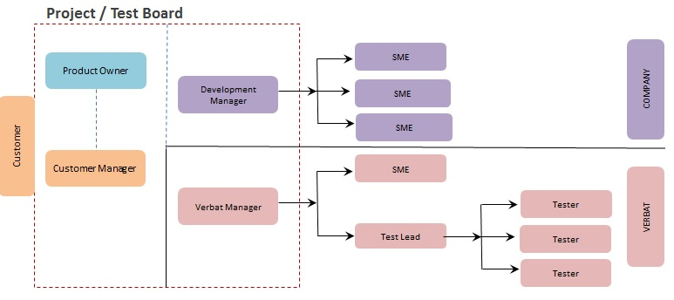

* The project is organised in accordance with the principles of PRINCE2
* The Project Board (PB):
  + It is envisaged that all members would be required at the Project Board meetings.
  + Responsibility for monitoring external events that will impact the project will be the responsibility of the Project Board.

Our service offerings within test governance:

* Definition and implementation of the organisational test strategy & test methodology
* Supply of standard testing templates to be used across different projects
* Identification and implementation of testing tools to be used across the entire organisation
* Implementation of a standard process to be used to raise and manage risks & issues
* Establishing a standard process to be used for estimating the testing effort
* Implementation of a test governance structure:
  + Bi monthly project board meeting
  + Weekly Report to the board on the progress

# General Terms and Conditions

* 1. This proposal is valid for a period of 60 days from the date of submission.
  2. All the project activities will be carried out from our off- shore development centre in India.
  3. All the documentation will be provided in English.
  4. For any circumstances if project needs to be put on Hold / Stop it requires minimum request notice period of 1 week along with duration for which request will be addressed by management and final decision on the request will be based on that.

# Company referees

## Client Name – Barcode Gulf

Barcode Gulf LLC, Dubai was created in November 2000. Over the last 11 years Barcode Gulf has been performing consistently with a healthy annual growth on turnover. Today Barcode Gulf is one of the leading Auto-ID & Mobility Solutions Providers in the Middle East region with 4 offices established in the United Arab Emirates, Qatar and Kuwait. Barcode Gulf is a company with mobile computing and wireless solutions as our core business activity. Barcode Gulf list of customers is testimony to the quality of their products and the reliability of our post sale support. They are dedicated to a business philosophy of delivering superior value, quality and service in response to defined customer needs. They will strive to ensure successful implementation of the project through innovative products, installation, training and on-going maintenance support.

Contact Person: Madhu Pallath

Designation: Director

Email: madhuvp@barcodegulf.net

## Client Name – CCC

CCC’s origins go back to 1952 when three talented young entrepreneurs, the late Kamel Abdul-Rahman, the late Hasib Sabbagh, and Said Khoury, joined forces to create one of the first Arab construction companies.

After decades of growth, CCC continues to practice the same style of management incorporated at its founding, a style based on mutual trust with clients, ease of communication, and smooth collaboration across locations and departments. Since the company’s humble beginnings, the CCC Group has expanded to include several subsidiaries, augmenting CCC’s regional and international status. Today, CCC leads the industry in the adoption of new technology to improve construction efficiency and enhance project controls.

Contact Person: Ammar Abu Hejleh

Designation: Area Commercial Manager

Email: [ammarah@ccc.ae](mailto:ammarah@ccc.ae)

# Our Other Clients



For more details visit www.verbat.com

For more details about our company visit us at www.verbat.com

We look forward to hearing from you soon and hope that you will give us the privilege to work with you   
in meeting your business goals. Thank you.



Disclaimer: This proposal would have been derived or concluded from either the RFQ /RFP/data shared via email / information transferred during an initial requirement analysis meeting /tele-conversation. Verbat Technologies reserves the right to change the terms of this proposal as the final terms (including the costing), features & functionalities could change during the course of the project. Hence any fees quoted in this proposal may not be considered as the final cost of the project unless agreed and signed by both parties.